# Design & Analysis of Algorithms

# Monsoon Semester III 2020-21

**Lab - 6** Date: **2 November 2020**

**Topics: Trees**

**AIM**

# In the lab we would be solving for BFS & DFS

**EXERCISE**

1. Implement BFS & DFS (Inorder Traversal) for a given Graph

[Breadth First Traversal (or Search)](http://en.wikipedia.org/wiki/Breadth-first_search) for a graph is similar to Breadth First Traversal of a tree. The only catch here is, unlike trees, graphs may contain cycles, so we may come to the same node again. To avoid processing a node more than once, we use a boolean visited array. For simplicity, it is assumed that all vertices are reachable from the starting vertex.

Depth First Search (DFS) algorithm traverses a graph in a depthward motion and uses a stack to remember to get the next vertex to start a search, when a dead end occurs in any iteration.

1. Check if a graph is strongly connected

In a directed graph is said to be strongly connected, when there is a path between each pair of vertices in one component.

To solve this algorithm, firstly, DFS algorithm is used to get the finish time of each vertex, now find the finish time of the transposed graph, then the vertices are sorted in descending order by topological sort.

1. Print pre & post visited times

[Depth First Search](https://www.geeksforgeeks.org/depth-first-search-or-dfs-for-a-graph/) (DFS) marks all the vertices of a graph as visited. So for making DFS useful, some additional information can also be stored. For instance, the order in which the vertices are visited while running DFS.  
Pre-visit and Post-visit numbers are the extra information that can be stored while running a DFS on a graph and which turns out to be really useful. Pre-visit number tells the time at which the node gets into the recursion stack and Post-visit number tells the time at which the node comes out from recursion stack of DFS.

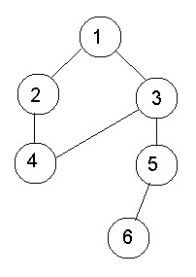

**ANALYSIS**

Running time for BFS = O(V)

Running time for DFS = O(V+E)

**OUTPUT**

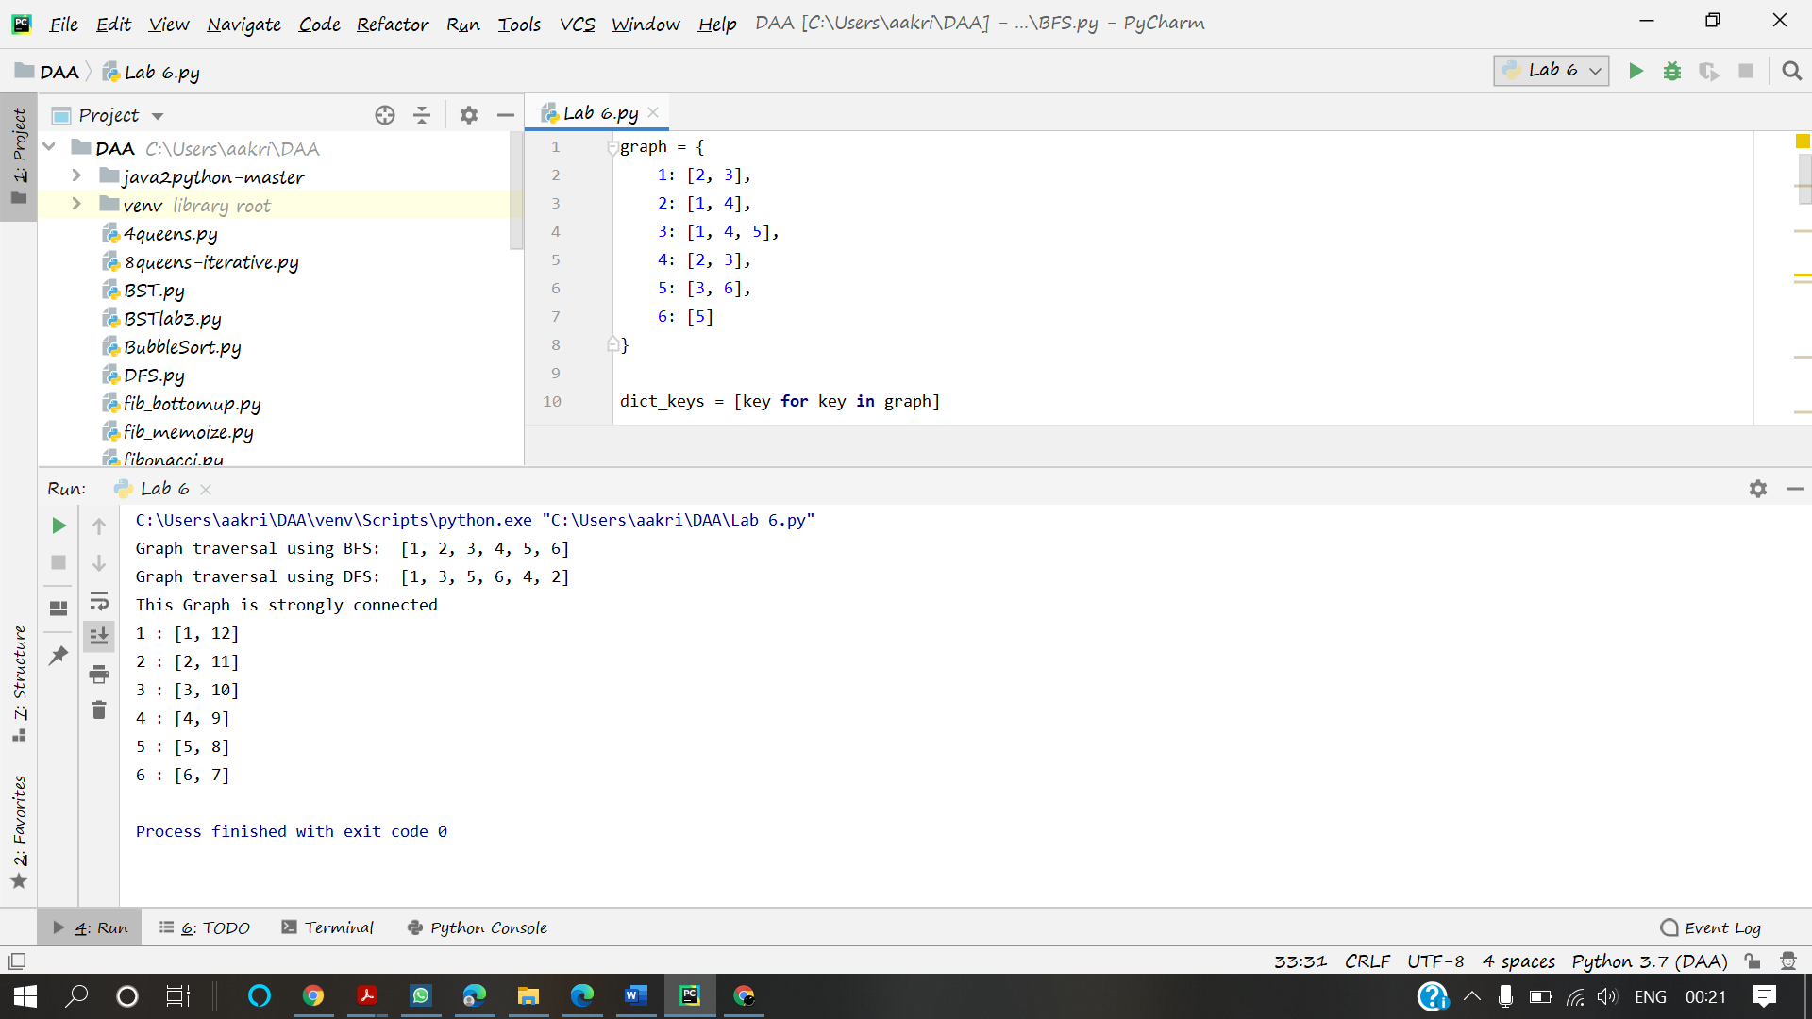

**CONCLUSION**

Hence, the BFS and DFS travels of the graphs has been implemented